How to email a custom list of people from registration system

Example I want to email all registrants that have registered to any role at my club in 2019

1. Create the custom person list that you want to communicate to
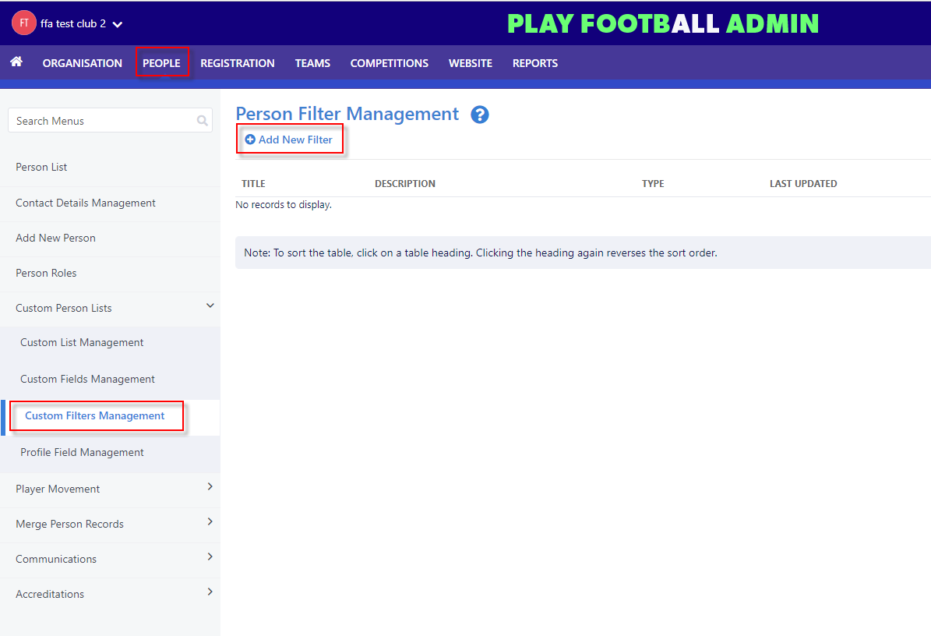

2. Give your custom person list a name and description, set the criteria you wish to filter on such as role, registration period, registration type etc – Click Preview
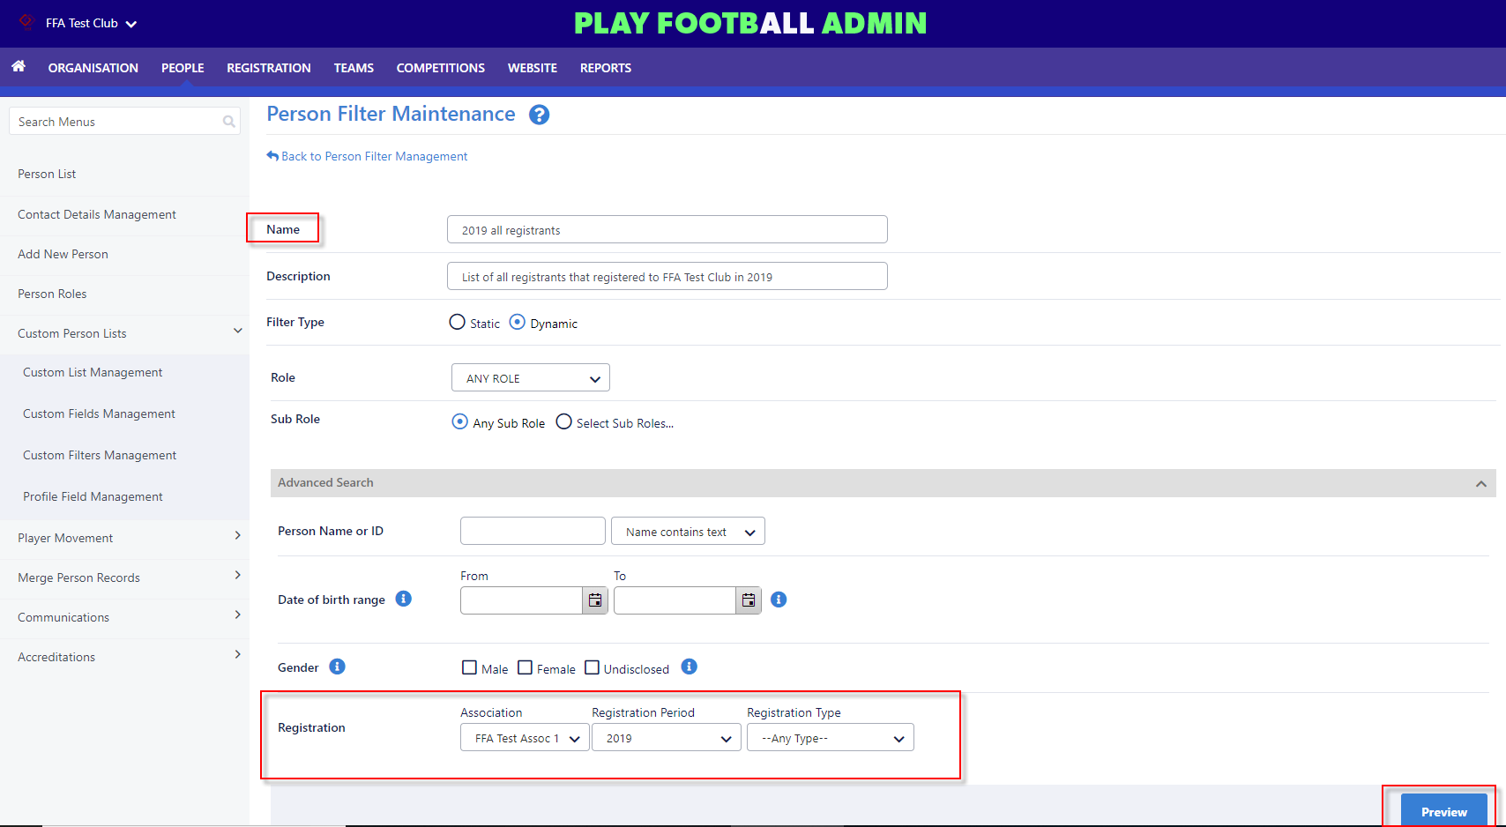

3. If you are happy with the list that has been generated, click save and click “Back to Person Filter Management” at the top of the screen
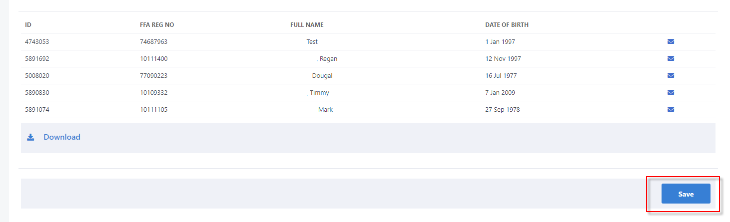

4. Navigate to People \ Communications \ Email People
Select the filter that you created earlier \ click Filter
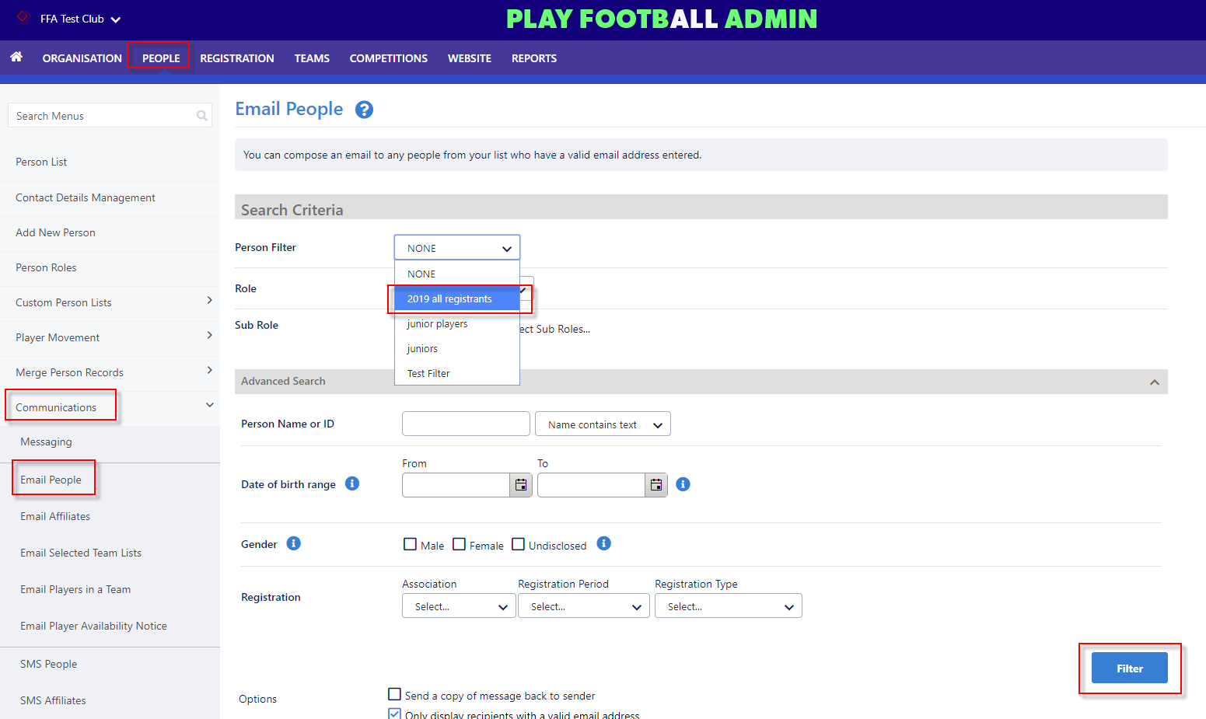

5. Add any additional recipients (if required), Subject, Message and attachment (if required)
