Online Payments – Onboarding

Clubs looking to accept online payments will need to onboard, the onboarding process comes in two phases.

Phase 1:
- Select Registration, then select ‘Bank Account Details’
- Enter in the Clubs BSB and Account number
- Select Update
Details listed on PlayFootball are used for verification purposes only and does not mean you are setup to accept online payments, please complete phase 2.

Phase 2:
- Select ‘Form’ (hyperlink located at the bottom of the Bank Account Details page)
- Complete the Online Payment Request Form
- Click ‘Submit Form’
[!] Your request is now PENDING; clubs will not be able to accept online payments until a confirmation email has been received

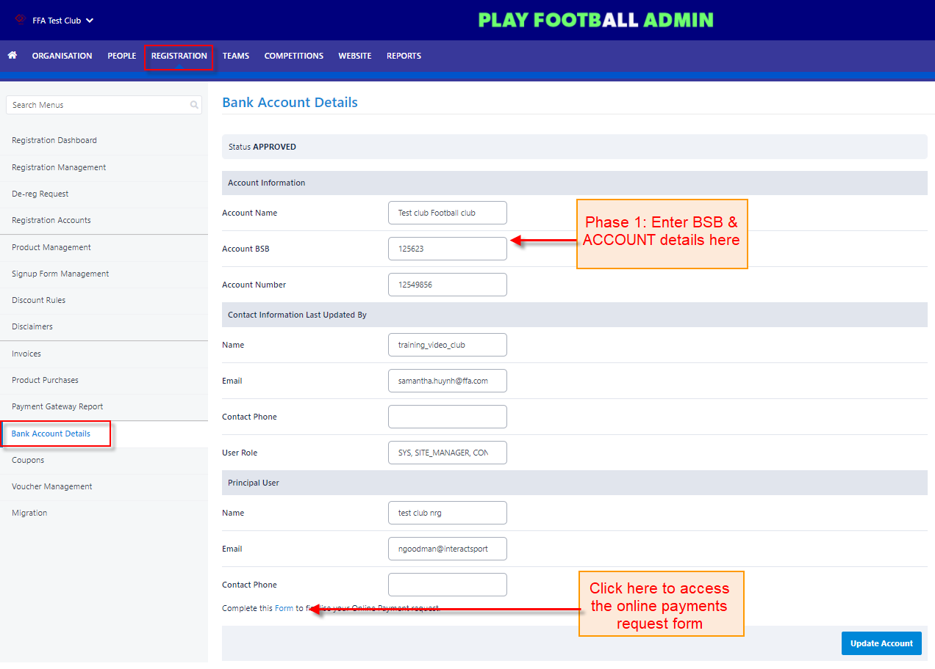
Click here for PlayFootball Admin login page

