Create a Registration Sign-up Form
Topics Covered

Create Membership form 1
1. Select Registration Form 3
2. General Settings 3
3. Payment Settings 5
4. Form Fields 6
5. Optional Products 7
6. Form Links 8

Menu: Registration> Sign up Form Management > Add Registration Form

Create Membership form
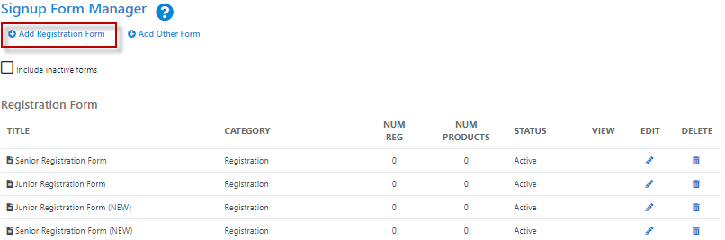

- Sign up forms provide Organisations with the ability to receive payments and process registrations online
- Click the Add New Online Registration Form link to create a new form or the Edit icon to make changes to an existing form.
- Some governing bodies have provided templates to assist their members in setting up forms and to ensure that the relevant data is captured. If no templates are available, blank forms can be created.
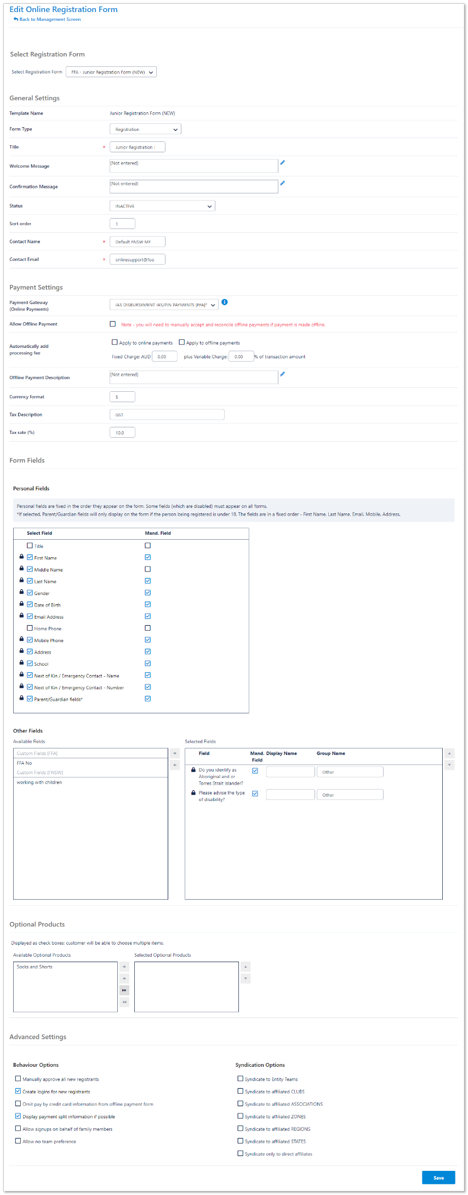
Forms set up can be broken down into the following 5 components:

- Select Registration Form

- General Settings

- Payment Settings

- Form Fields -
Personal Fields
Other Fields

- Optional Products

Select Registration Form
- FFA will have a set of templates that Organisations will be able to select as a base. The difference in forms will reflect the different information participants require as junior or seniors. i.e. Junior forms will capture more information compared to a senior player’s sign-up form

General Settings
- The general settings will have locked fields which will be set in the template created by FFA.
- Organisations are to add the pre-created disclaimer in this section

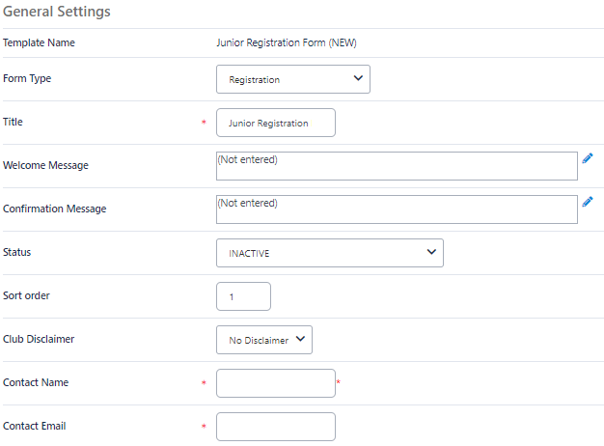

General Settings | Definition
Form Type | The form type determines some overall purpose of the form. Different types will be available for different organisations and each type may have different behaviour: Standard Registration Form: Used for registering a member to an organisation or event.
Title | This displays at the top of the Sign-up form.
Welcome Message | Text entered here will display at the top on the Welcome Page. Click on Edit to open the HTML editor that can be used to add style to the text.
Confirmation Message | The Text entered here will display at the end of the registration process. Click on Edit to open the HTML editor that can be used to add style to the text.
Status | ACTIVE - the form is publicly available and may be accessed via the Public Access URLs or via the club finder in the public portal.  INACTIVE - the form is not publicly available and can only be previewed with the provided links.  TEST MODES - the form is only available by clicking the Public Access URLs.  When in test mode, the public form displays a red label indicating that it is in test mode. Forms that are being set up should be set to test mode and only switched to ACTIVE when they have been finalised.  Anyone trying to access a form when in TEST MODE, without the correct access URL, will be denied access.  TEST MODE ACCESS, TEST MODE GATEWAY - When both the form and payment gateway are set to test mode (if the gateway supports it) then transactions made through the form will establish a connection to your gateway but no funds will be processed. All gateways have different ways of operating under test mode. Contact support for more information.  TEST MODE ACCESS, PROD MODE GATEWAY - When the form is in test mode and the payment gateway is set to production mode, a real card must be supplied for live gateway testing.  If the SIMULATED gateway is selected(see below) funds are never processed regardless of the TEST MODE selected above.
Disclaimer | Governing bodies may have a predefined disclaimer that must be used. Some organisations will be able to create their own disclaimers. A disclaimer will contain the terms of use for your sign-up form and must be agreed to before the sign-up process can be completed.
Contact Name | Enter the name of the person or organisation that should be contacted with any queries relating to this form. Also, any confirmation emails sent to customers are sent from this name.
Contact Email | Enter the email address that queries will be sent to. Also, any confirmation emails sent to customers are sent from this address, and their replies will come back to this address.

Payment Settings
Payment setting are to be set in this section of the Signup form, Organisations will need to decide if they are accepting offline payments for the upcoming season in this section.

NOTE: IP Payment System will be the Payment gateway providers for the 2019 season. If your Organisation requires access, please speak with your Member Federation directly.
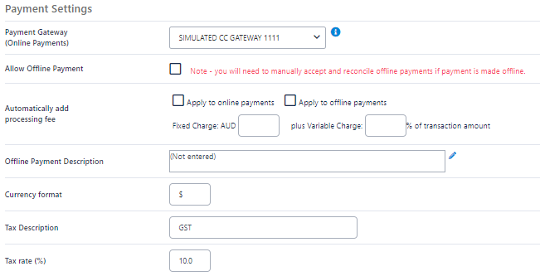

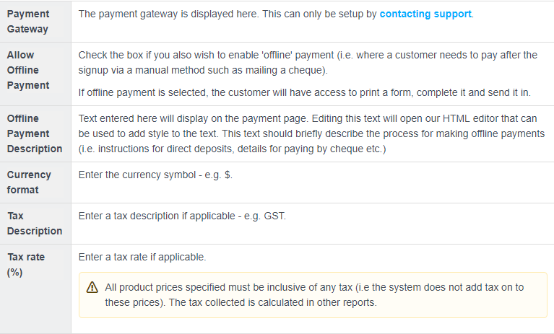
Form Fields
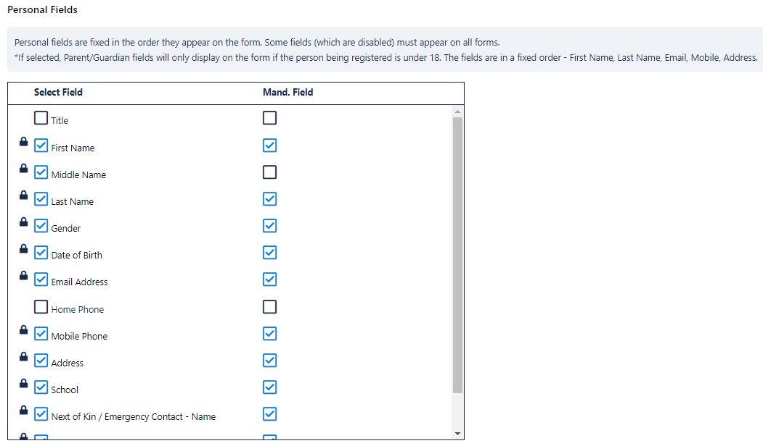
- FFA’s template will have Locked fields that cannot be removed by Organisations, additional fields can be added and made mandatory by organisations.

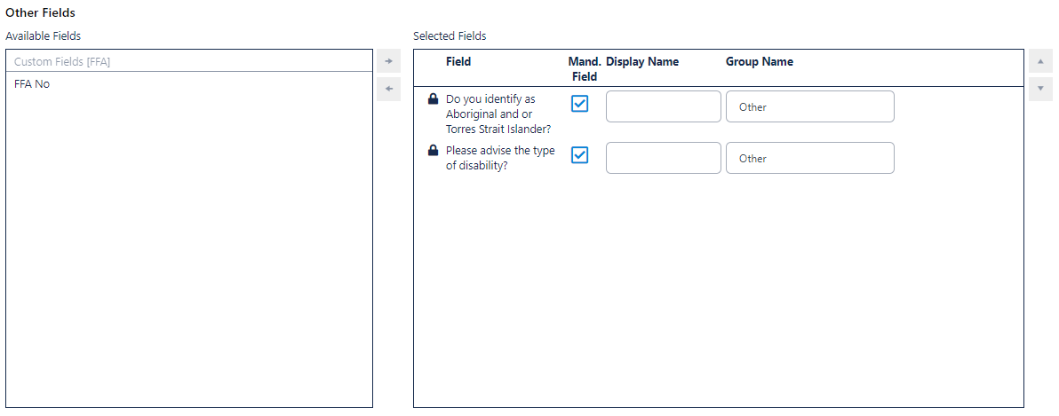

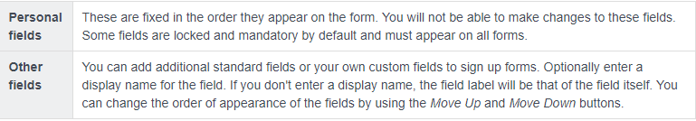

Optional Products
Optional products allow organisations to offer optional products to their registrants
- Products need to be added prior to creating the signup form – create products Menu: Registration>product management > Add Other Product
- Optional product examples: shorts, socks, hats or events etc.

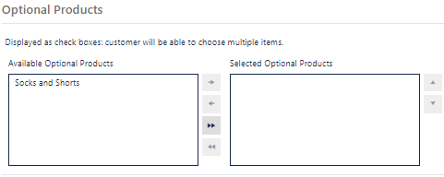

Form Links

